SE ENABLEMENT PLATFORM
New-Hire Onboarding Workflow
Step-by-step guide for hiring managers, mentors and new hires

Version: 1.0, October 27, 2026
Walkthrough: recorded end to end on the live platform with three test accounts: Bill Smith (hiring manager), Matt Giblin (mentor) and Kevin Jones (new hire).
Audience: SE managers, mentors, new Solutions Engineers and enablement administrators.

Contents
Contents
Overview
Who does what
The workflow at a glance
Rules that shape the workflow
Section 1 — Hiring manager: set up the new hire
Section 2 — Mentor: meet the new hire and set the schedule
Section 3 — New hire: work through the ramp
Section 4 — Review and progress
Mentor: review a submitted step
Hiring manager: check progress
Appendix A — Notifications
Appendix B — Quality notes from the walkthrough

Overview
Onboarding a new Solutions Engineer involves three people. The hiring manager sets the new hire up and owns the stage gates. The mentor meets the new hire, agrees the due dates with them and reviews their everyday work. The new hire works through the ramp plan one step at a time.
This guide follows that order. Each section starts again at step 1, and every step explains why it matters. Screens are shown as they appear in the platform; text visible in them is example content from the walkthrough. The Fill in boxes describe what you enter.

Who does what
Role | In this walkthrough | Responsibilities
Hiring manager | Bill Smith | Writes the hiring brief, assigns the onboarding program and the mentor, schedules 1:1s, signs off every stage gate and watches progress.
Mentor | Matt Giblin | Reads the brief, holds the first 1:1, sets the due dates with the new hire, approves or sends back everyday steps and logs check-ins.
New hire | Kevin Jones | Works through the ramp plan, submits each step with evidence and acts on feedback from the mentor.

The workflow at a glance
Phase | Who | Outcome
1 | Hiring manager | The new hire has a hiring brief, a mentor and a four-stage onboarding program (Days 1–30 to Days 91–120).
2 | Mentor | The first 1:1 has happened and the due dates are agreed. The new hire and manager are told.
3 | New hire | Steps are completed and submitted with evidence.
4 | Mentor and manager | The mentor approves or sends back everyday steps. The manager signs off stage gates and tracks progress.

Rules that shape the workflow
- The mentor sets the due dates. The template's dates are only a starting point. The mentor agrees the real dates with the new hire at their first meeting, and the platform tells the new hire and the manager straight away. No approval is needed.
- The mentor approves everyday steps. Reading, pitches, knowledge checks, challenges and simulations go to the mentor.
- The manager signs off stage gates. Test-outs and the end-of-stage sign-off unlock the next stage, so they stay with the hiring manager.
- Mentoring appears only for mentors. The Mentoring area shows in the sidebar only for people assigned as someone's mentor.
- Details open in a workbench. Clicking a person, step or item opens a full popup workbench over the page. Press Esc or the close button to return.

Section 1 — Hiring manager: set up the new hire
Signed in as the hiring manager. Before you start, the new hire must have an account and report to you.

1. Find the new hire on Today
- Open Today from the sidebar.
- Find the new hire under Your team, most urgent first. A new starter shows New to the team, no ramp plan yet.

Why it matters: Today lists everyone who needs you, most urgent first. A new starter is flagged for onboarding, not as at risk, so you can see straight away what to do.
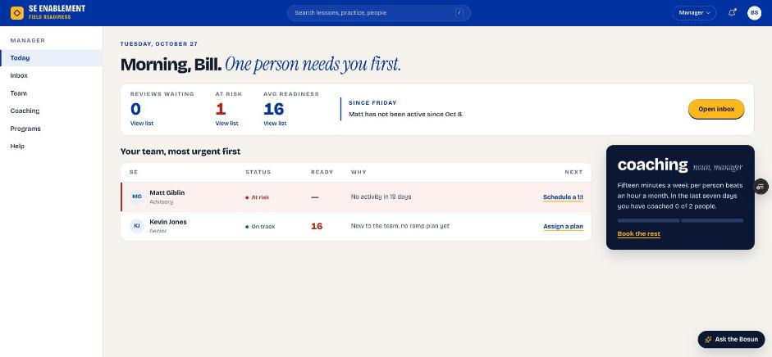
Figure 1.1 — Manager Today page with the new hire waiting for a plan

2. Open the new hire's profile workbench
- Click the new hire's name. Their profile opens as a workbench.
- The left side shows the overview, counters and onboarding steps. The right side holds Mentor and notes.

Why it matters: Everything you need for onboarding is in one place: the brief, the mentor, the plan and the 1:1 scheduler. You don't need to move between pages.
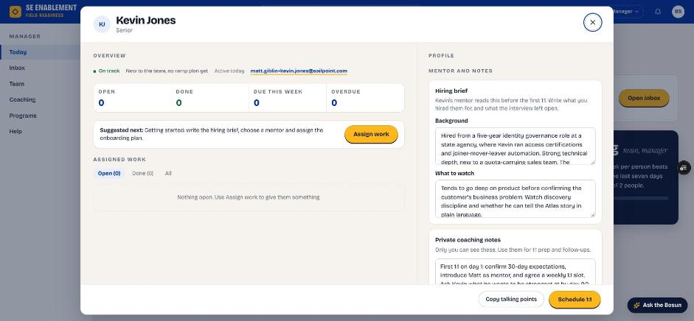
Figure 1.2 — The profile workbench

3. Write the hiring brief
- In Hiring brief, complete both fields.
- Click Save hiring brief. A confirmation says the mentor can now see it.

Fill in: Background: what you hired this person for: their experience, strengths and the role they're stepping into. What to watch: what the interviews left open and what the mentor should keep an eye on in the first weeks.

Why it matters: The mentor reads the brief before the first 1:1. It gives them the context to coach from day one instead of starting cold.
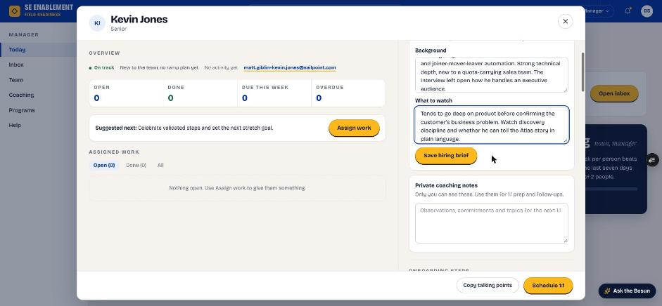
Figure 1.3 — Hiring brief fields
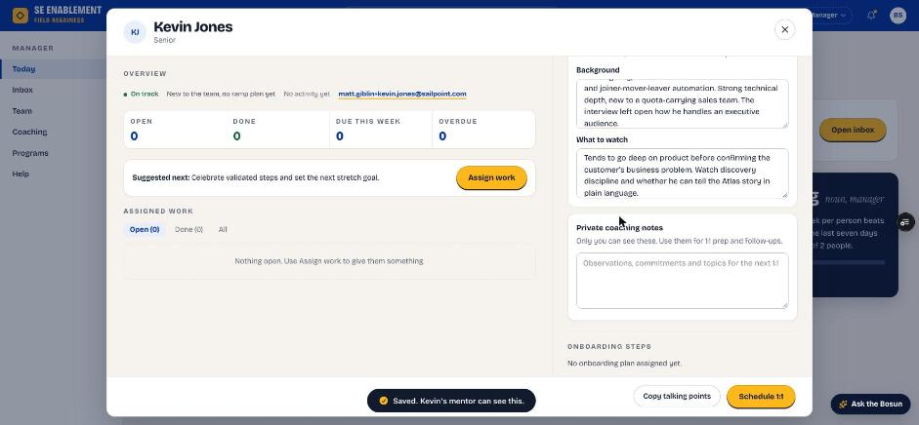
Figure 1.4 — Brief saved and shared with the mentor

4. Add private coaching notes
- In Private coaching notes, add your own notes.
- Click Save notes.

Fill in: Your goals for the first 1:1, anything to follow up on, and what you want the new hire to be strongest at by the end of the program. Only you can see these notes.

Why it matters: These notes are your preparation for 1:1s and follow-ups. They stay private, so you can be candid.
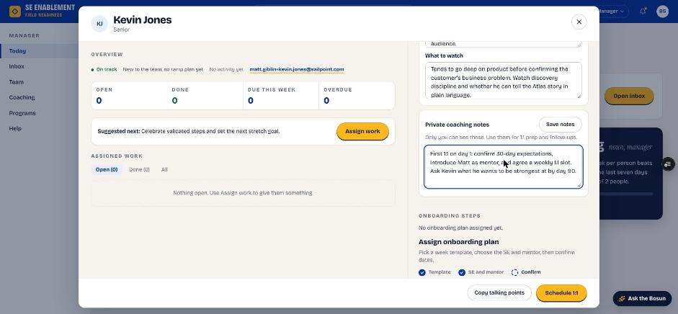
Figure 1.5 — Private coaching notes
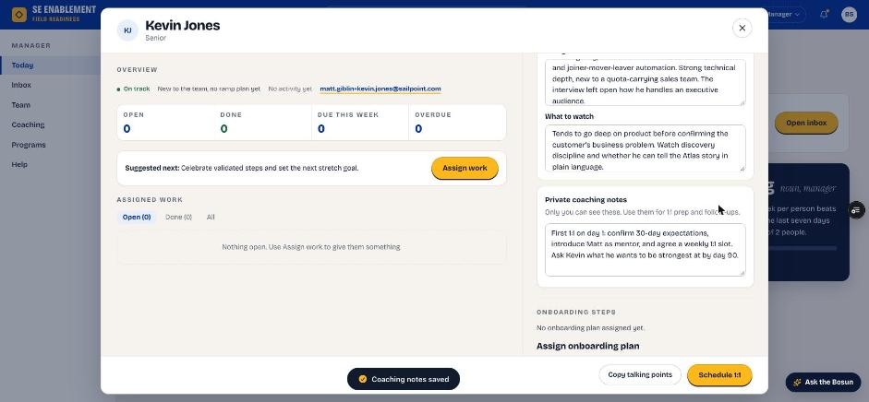
Figure 1.6 — Notes saved

5. Choose the onboarding template
- Scroll to Onboarding steps and choose Assign onboarding plan.
- Under Step 1, Template, choose the first stage of the new-hire program (Days 1–30 — Foundation). Check the stage length and step count.

Why it matters: The program has four 30-day stages. Assigning the first stage starts the program, and later stages unlock as each stage gate is signed off.
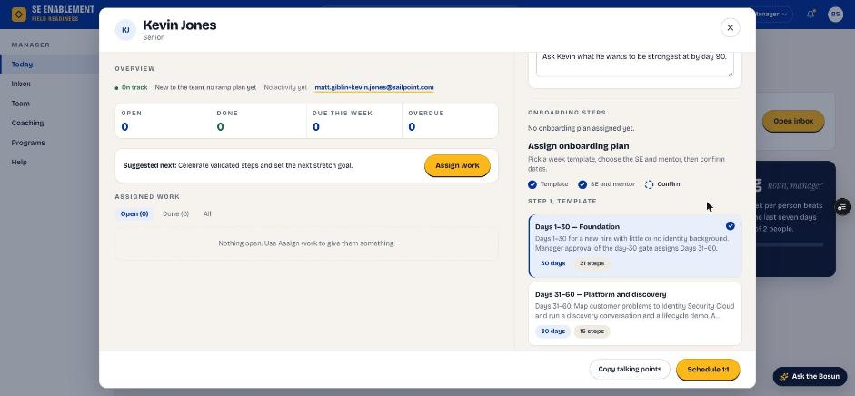
Figure 1.7 — Choosing the Days 1–30 template

6. Choose the person, mentor and start date
- Assign to: the new hire.
- Mentor: an experienced SE who will coach them. The list doesn't include the new hire themselves.
- Start date: the new hire's first day.
- Target completion fills in from the template.

Fill in: Assign to, Mentor and Start date. Leave Target completion as suggested; the mentor will confirm the final dates.

Why it matters: The mentor you choose is who the new hire works with every week and who reviews their everyday steps. Target completion is a starting point because the mentor agrees the real dates with the new hire.
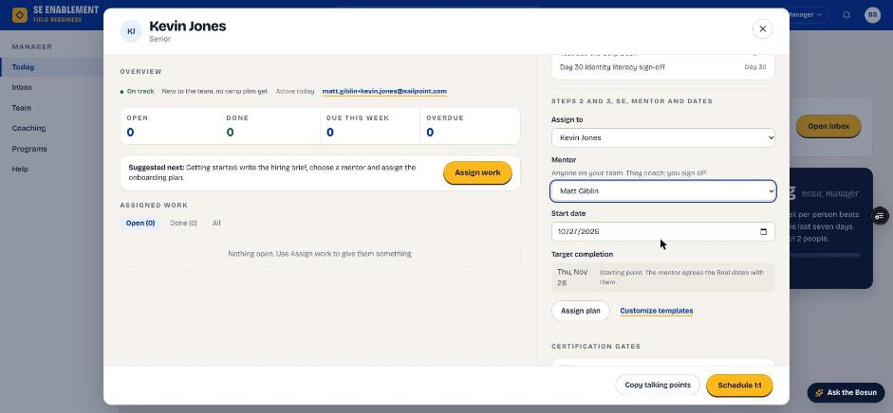
Figure 1.8 — Assign to, mentor, start date and target completion

7. Assign the plan
- Click Assign plan.
- The profile stays open, the steps appear with their starting dates, and a confirmation appears.

Why it matters: Assigning notifies both people. The new hire is told who their mentor is and that dates are agreed at the first 1:1. The mentor is told they've been chosen and what to do next.
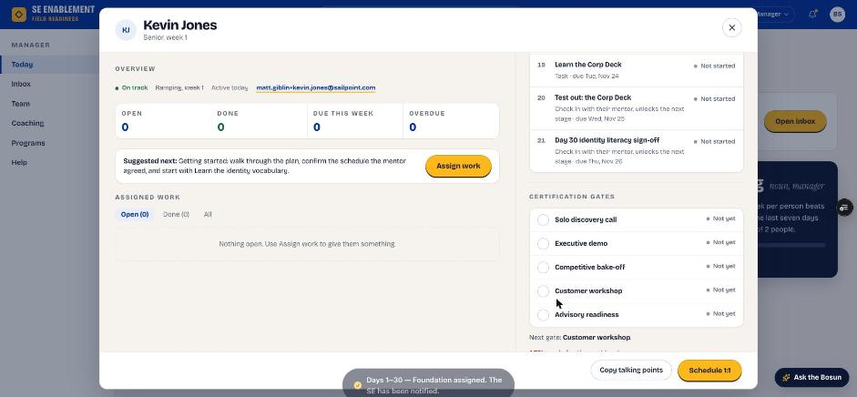
Figure 1.9 — Plan assigned; the new hire has been notified
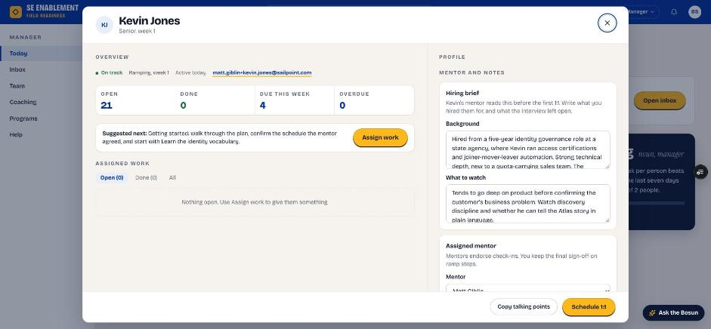
Figure 1.10 — Profile after assignment: counters, brief and mentor

8. Schedule a 1:1 with the new hire
- In the profile footer, click Schedule 1:1.
- Pick the date, time and length, and choose whether the mentor joins.
- Click Schedule and download invite, then open the downloaded invite to send it from your calendar.

Fill in: Date, time and length of the meeting. Tick the mentor box if they should join.

Why it matters: The 1:1 is saved in the platform. The new hire sees it under Coming up on their Today page, they (and the mentor, if invited) get a notification, and the profile shows Next 1:1.
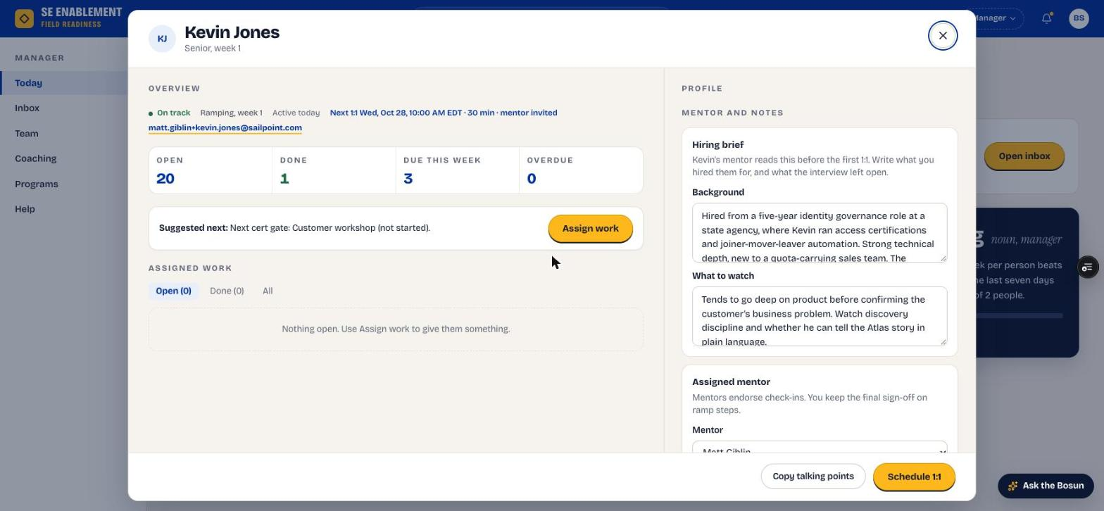
Figure 1.11 — The profile shows the next 1:1 and whether the mentor is invited

Section 2 — Mentor: meet the new hire and set the schedule
Signed in as the mentor. The Mentoring area appears in your sidebar once you're assigned as someone's mentor.

1. See your new mentee on Today
- Open Today. The You're mentoring card names the new hire and the next move: read the hiring brief, meet them, then set the schedule together.

Why it matters: Your first job is clear from the moment you sign in, without having to find it in notifications.
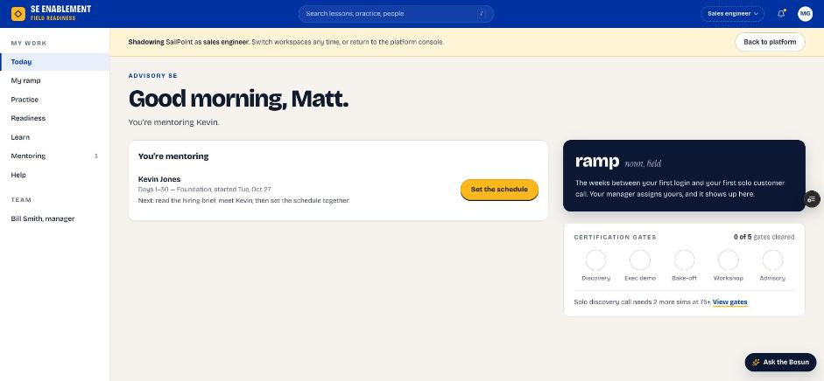
Figure 2.1 — Mentor Today page with the You're mentoring card

2. Open Mentoring
- Click Mentoring in the sidebar.
- Each mentee has a row showing their program, progress and anything waiting on you.

Why it matters: Mentoring is your home for every mentee. It shows who needs a meeting, a schedule or a review.
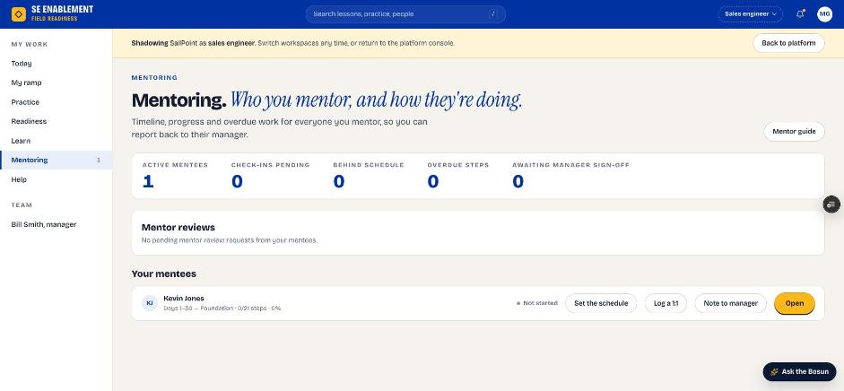
Figure 2.2 — Mentoring page

3. Open the mentee workbench and read the hiring brief
- Click the mentee's name or Open.
- The workbench shows the program, dates and steps on the left, and the hiring brief and your coaching notes on the right.
- Read the brief before you meet.

Why it matters: The brief tells you what the manager hired for and what to watch. Reading it first makes the first 1:1 focused.
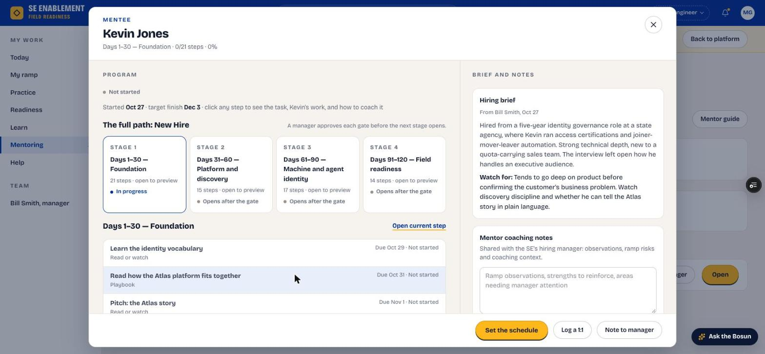
Figure 2.3 — Mentee workbench with the hiring brief

4. Preview the stages
- Click a stage card to open its steps in a step workbench.

Why it matters: Knowing what's coming lets you agree realistic dates and point the new hire at the right preparation.
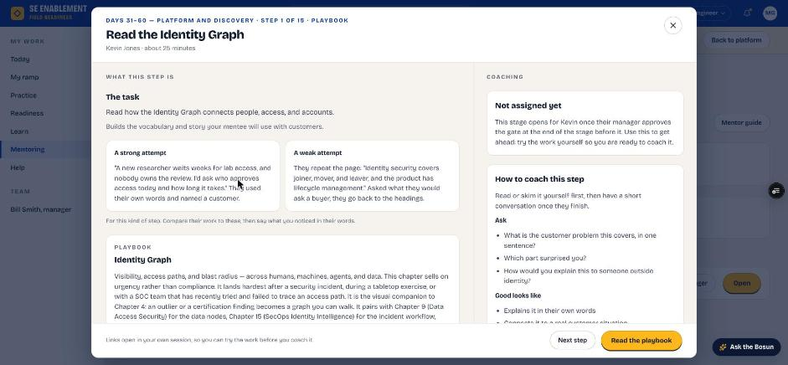
Figure 2.4 — Previewing a later stage

5. Hold the first 1:1 and log it
- Meet the new hire.
- In the workbench footer, click Log a 1:1.
- Record the meeting and save.

Fill in: Agenda: what you covered. Notes: what you learned about the new hire. Next actions: what they will do before you next meet.

Why it matters: The new hire receives the next actions as a notification, and the profile shows when you last met, so the manager can see the relationship is working.
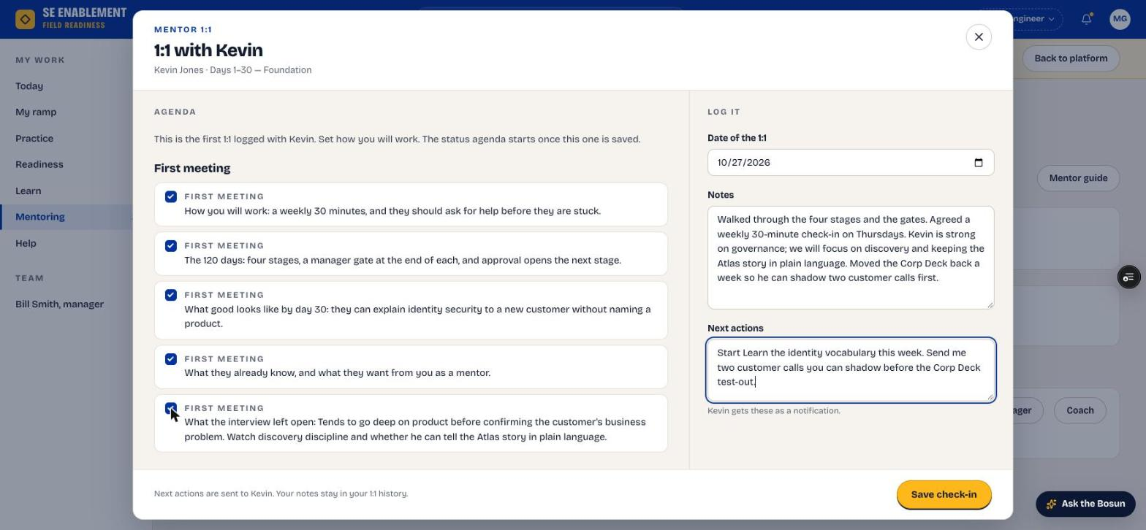
Figure 2.5 — Logging the first 1:1
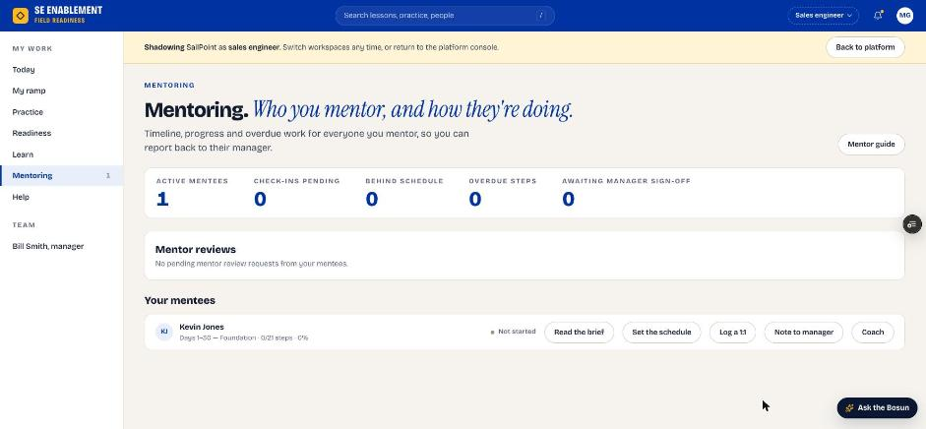
Figure 2.6 — Mentoring page after the 1:1

6. Set the schedule together
- In the workbench footer, click Set the schedule.
- Adjust the due dates you agreed with the new hire. The stage end date moves with them.
- Add a note explaining any changes, then click Set to save.

Fill in: The due dates you agreed, and a short note on why any date moved.

Why it matters: The mentor owns the dates because they agreed them face to face. They apply immediately, without approval, and the new hire and manager are both told.
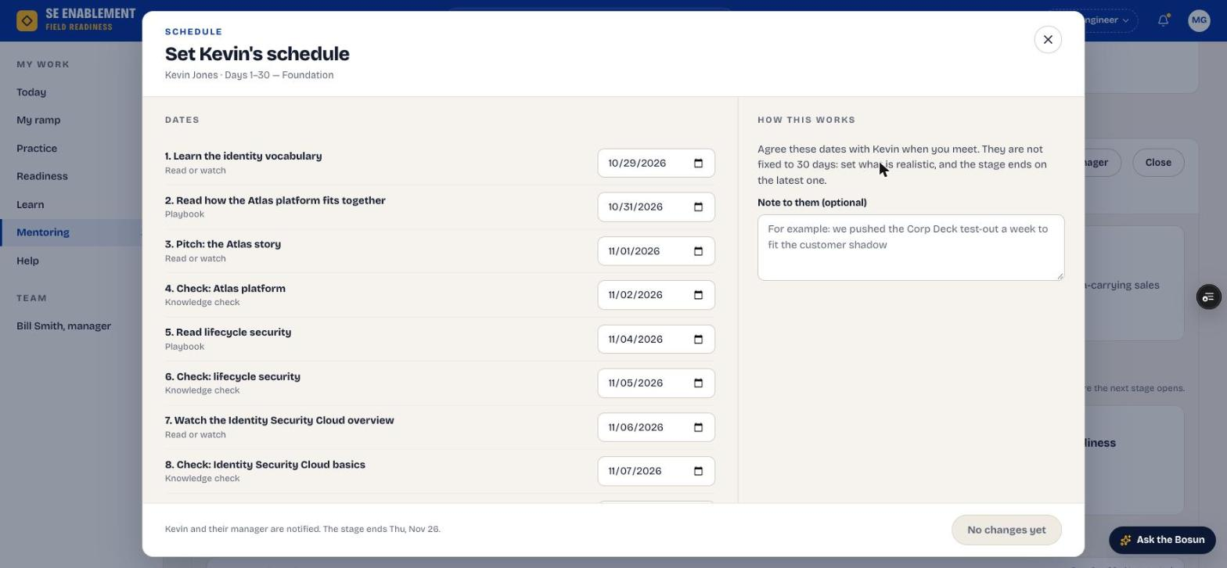
Figure 2.7 — Set the schedule
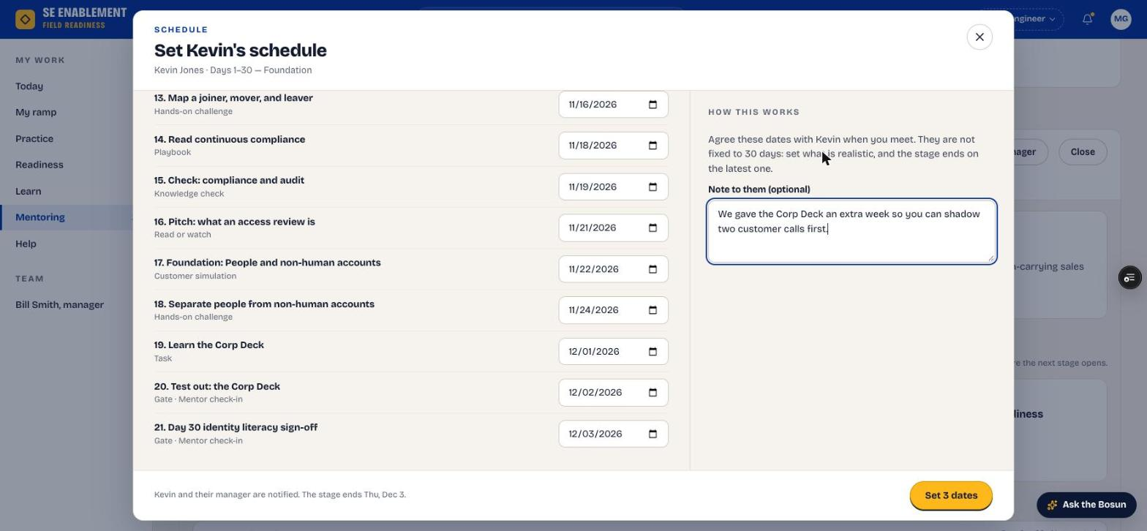
Figure 2.8 — Dates changed; the stage end moves

7. Confirm everyone was told
- A confirmation shows that the new hire and their manager were notified.

Why it matters: Everyone works from the same dates. The manager's Inbox also lists the change under Schedule changes by mentors, for information.
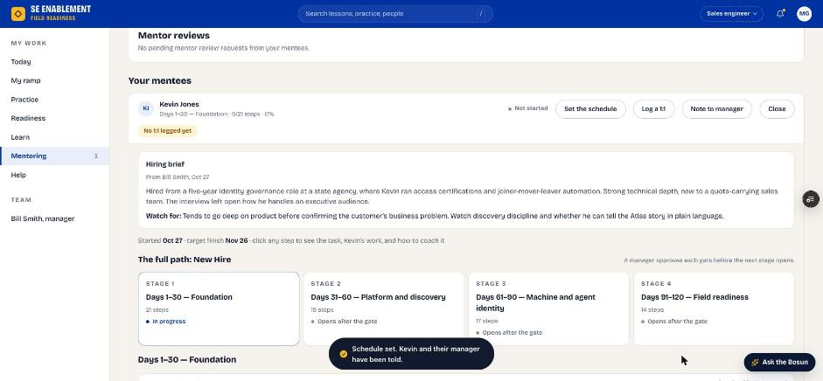
Figure 2.9 — Schedule saved and shared

Section 3 — New hire: work through the ramp
Signed in as the new hire.

1. Start on Today
- Today shows your next step, its due date and who reviews it, what's coming up, and the Your mentor card.
- Any 1:1 your manager has scheduled appears under Coming up.

Why it matters: Today always answers "what do I do next?", so you never have to work out where you are in the program.
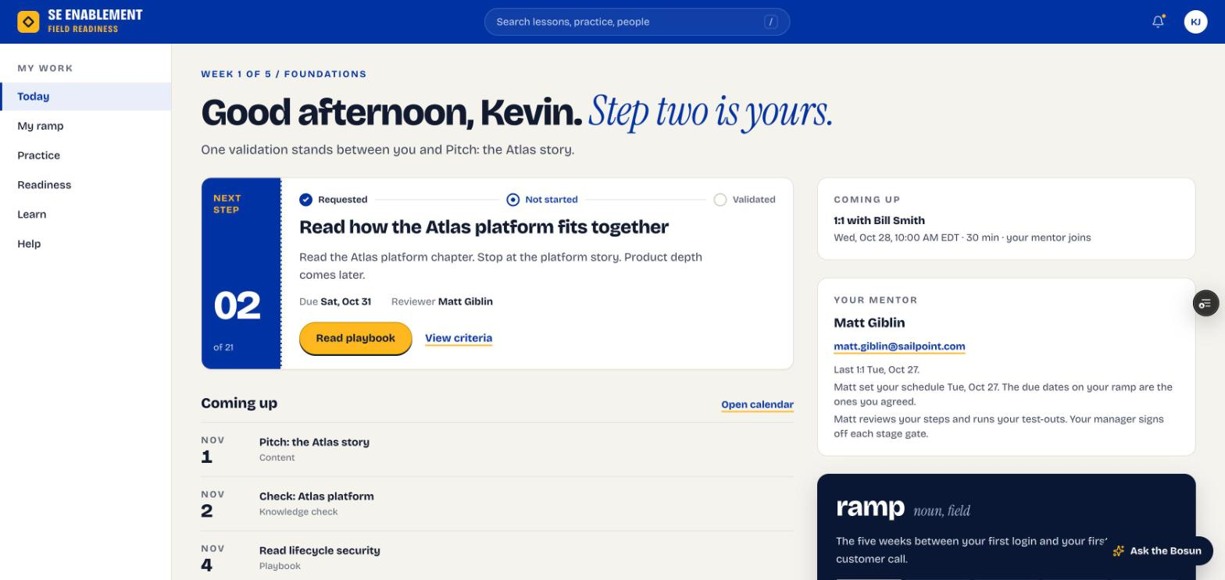
Figure 3.1 — New hire Today page

2. Check your notifications
- Click the bell. Your notifications open in a workbench: the plan assignment, the schedule your mentor set (with their note), the next actions from your 1:1, reviews of your steps and any 1:1 your manager scheduled.
- Click a notification to go to it, or Mark all read.

Why it matters: Notifications confirm who your mentor is, the dates you agreed and what you promised to do next.
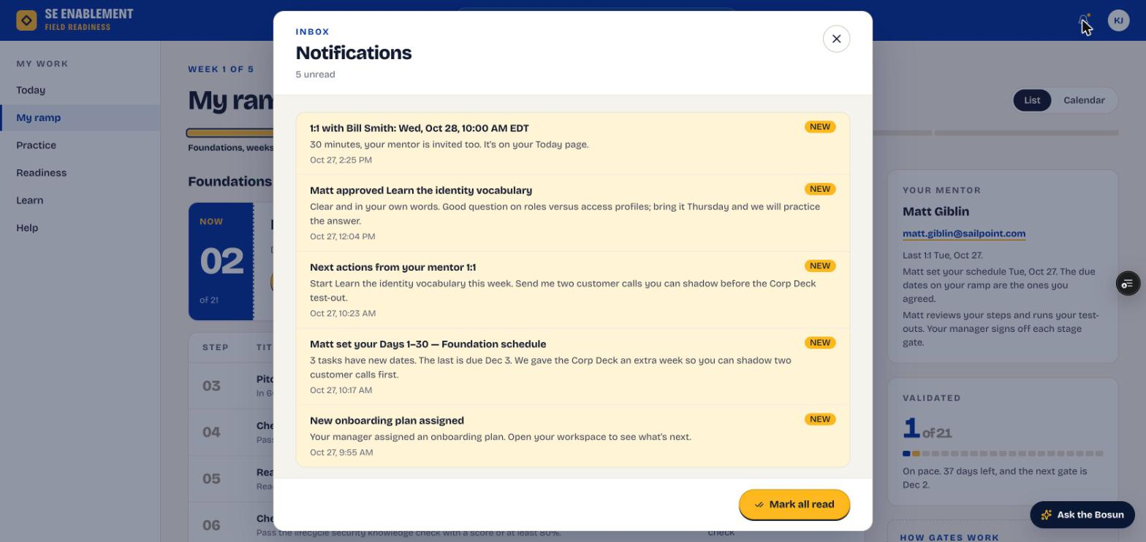
Figure 3.2 — Notifications

3. Open My ramp
- Click My ramp. You see the current step, every step with its agreed due date, your progress and your mentor.

Why it matters: The full plan with real dates helps you pace the 30 days and spot anything that needs to move early.
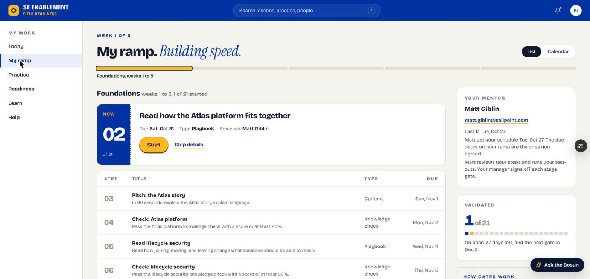
Figure 3.3 — My ramp

4. Complete and submit a step
- Click a step. It opens as a workbench over My ramp.
- Read the brief and the Done when criteria, and open the linked resource.
- Tick each criterion as you meet it, write your evidence and click Submit for review. The note under the evidence box says who reviews it.
- Playbook steps complete themselves when you finish the chapter; knowledge checks complete when you pass.

Fill in: What did you learn? Your evidence in your own words: the key takeaways, set against the Done when criteria, and any questions for your next 1:1.

Why it matters: Your evidence is what your reviewer judges. Clear evidence gets a quick approval instead of a send-back.
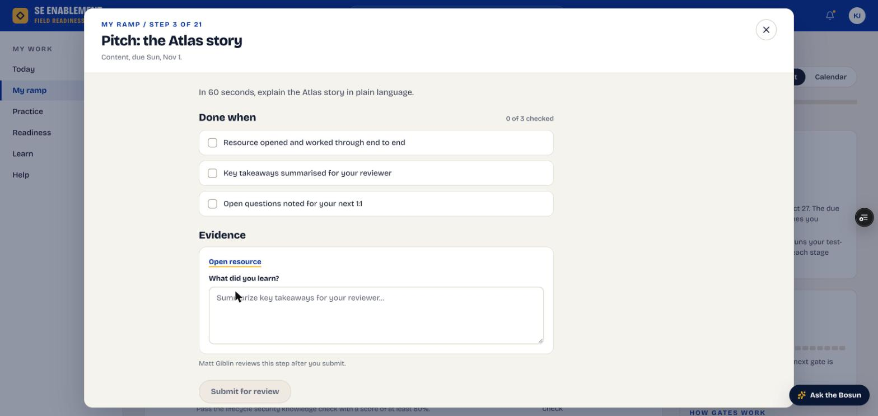
Figure 3.4 — Step workbench: Done when criteria, evidence and reviewer

5. Know what happens next
- The step shows In review on My ramp.
- Today says who has it (for example, "Step one is with Matt") and shows the next step so you can keep going.
- When your mentor approves or sends it back, you get a notification with their note (see Figure 3.2).

Why it matters: You don't have to wait idle. Your reviewer is notified, and you can move on to the next step.

Section 4 — Review and progress
The mentor reviews everyday steps. The hiring manager signs off stage gates and keeps an eye on progress.

Mentor: review a submitted step

1. See that work is waiting
- On Today, the You're mentoring card says how many steps are waiting on your review. Click Review.

Why it matters: Reviews are what keep the new hire moving. Surfacing them on Today means they don't sit unnoticed.
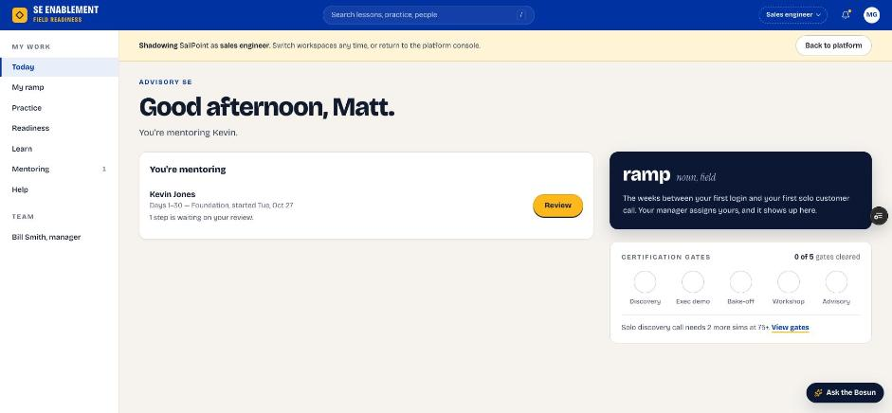
Figure 4.1 — A step waiting on the mentor's review

2. Find it on Mentoring
- The Waiting on your review counter and the mentee's row both show the submitted step.

Why it matters: With several mentees, this is where you see everything waiting on you at once.
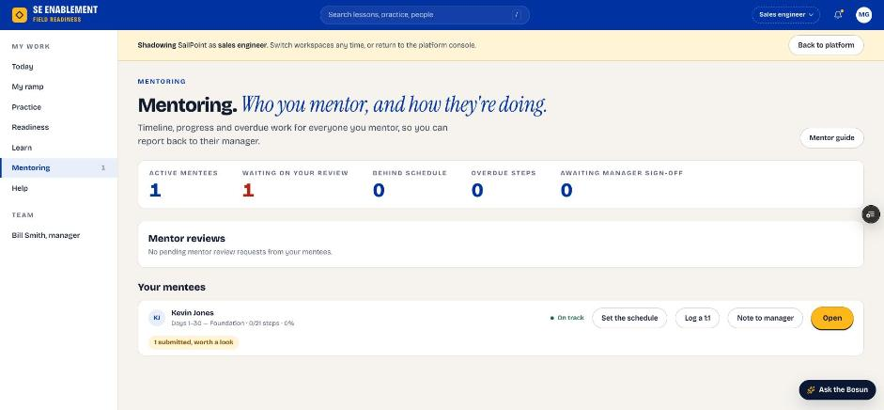
Figure 4.2 — Waiting on your review

3. Approve or send back
- Open the step. You see the new hire's answer and a Your review panel.
- Add a note, then click Approve, or Send back if it needs more work.

Fill in: A short review note: what was good, and what to change if you're sending it back.

Why it matters: The new hire's answer is kept as submitted, and your note reaches them as feedback. Approving counts the step toward their progress. Stage gates don't show these buttons because the manager signs them off.
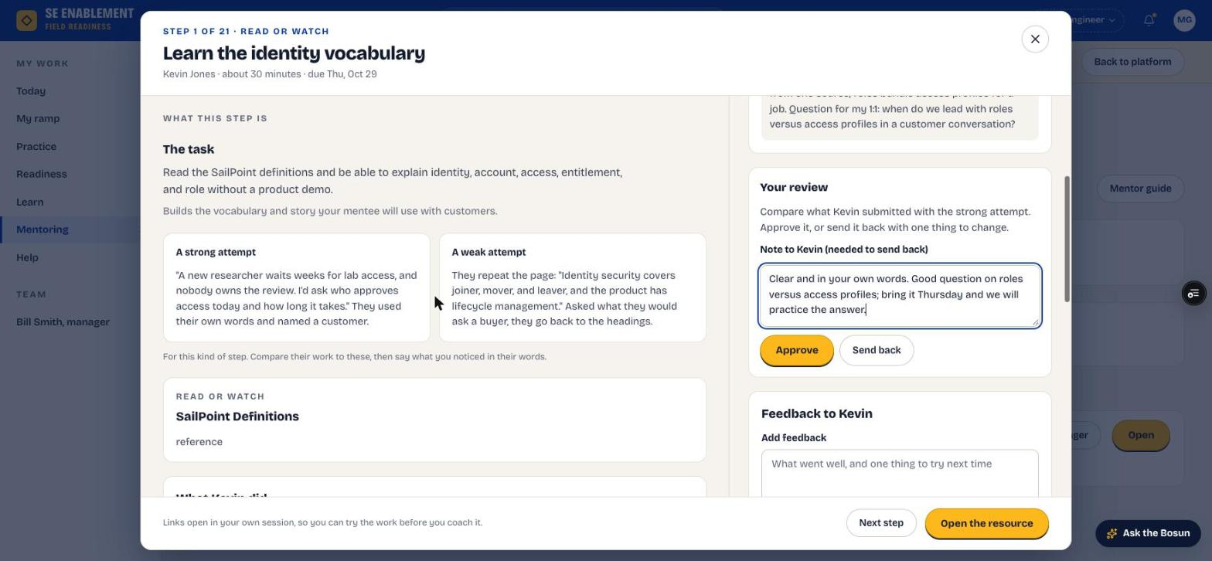
Figure 4.3 — Reviewing the new hire's step

4. Confirm the result
- The mentee's progress moves on and nothing is left waiting. The new hire is told the step was approved, with your note.

Why it matters: Both sides see the same status, so there's no doubt about where the step stands.
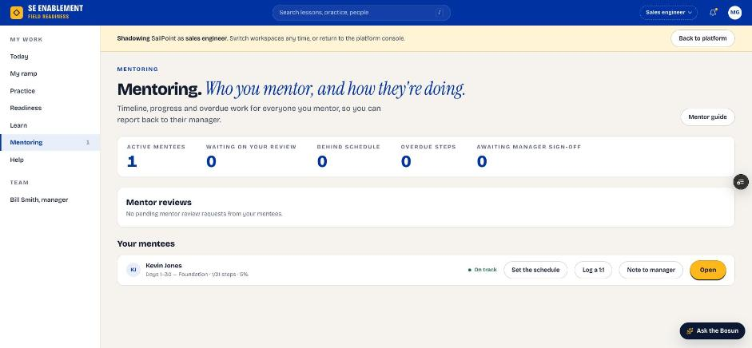
Figure 4.4 — Mentoring after approval

Hiring manager: check progress

1. Read Today
- Since Friday summarises what the team did, such as "Kevin finished a ramp step".
- Each person's status, readiness and suggested next action are listed. A new hire in their first 30 days shows Ramping, week N.
- A mentor's reviews, schedules and 1:1s count as them being active.

Why it matters: You can see progress at a glance without approving every step yourself. Your attention goes to the people who need it.
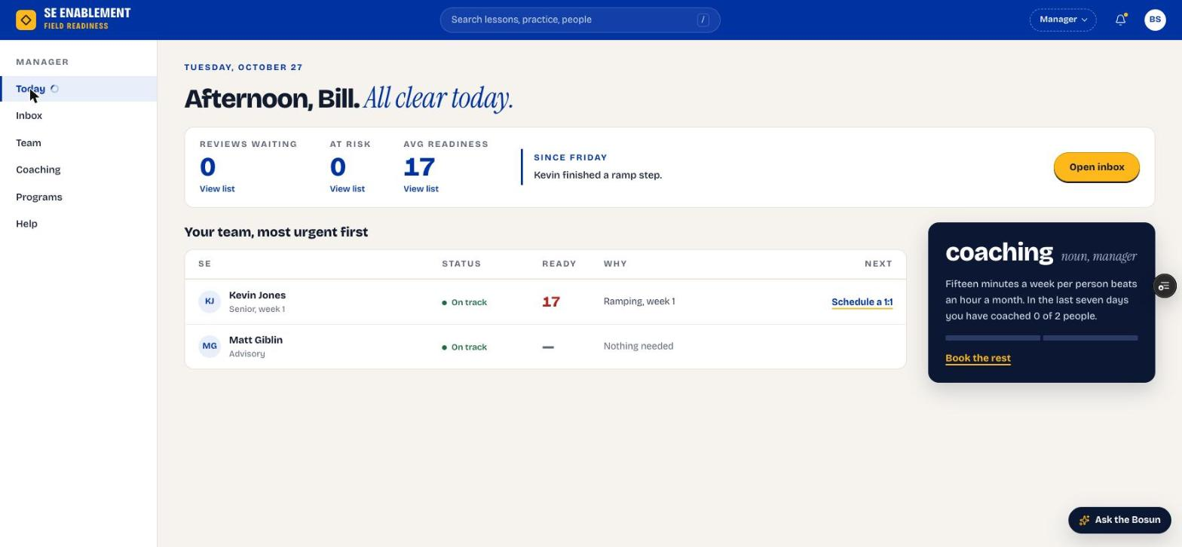
Figure 4.5 — Manager Today page after the first step

2. Open the new hire's profile
- Click the name. The counters show open, done, due this week and overdue steps.
- Onboarding steps lists every step with its agreed date. Stage gates read Stage gate, you sign off.
- Recent activity shows who approved what, the mentor's 1:1s and the schedule.
- Next 1:1 shows the next scheduled meeting.

Why it matters: The profile is the full picture for your next 1:1: progress, the mentor's involvement and what's coming up.
Figure 4.6 — Profile with progress and the next 1:1

3. Check the Inbox
- Open Inbox. Items that need your sign-off, such as stage gates, are listed oldest first.
- Schedule changes by mentors shows the dates mentors set, for information.

Why it matters: The Inbox holds only what needs your decision, so you can clear it quickly. Everyday steps go to the mentor and don't appear here.
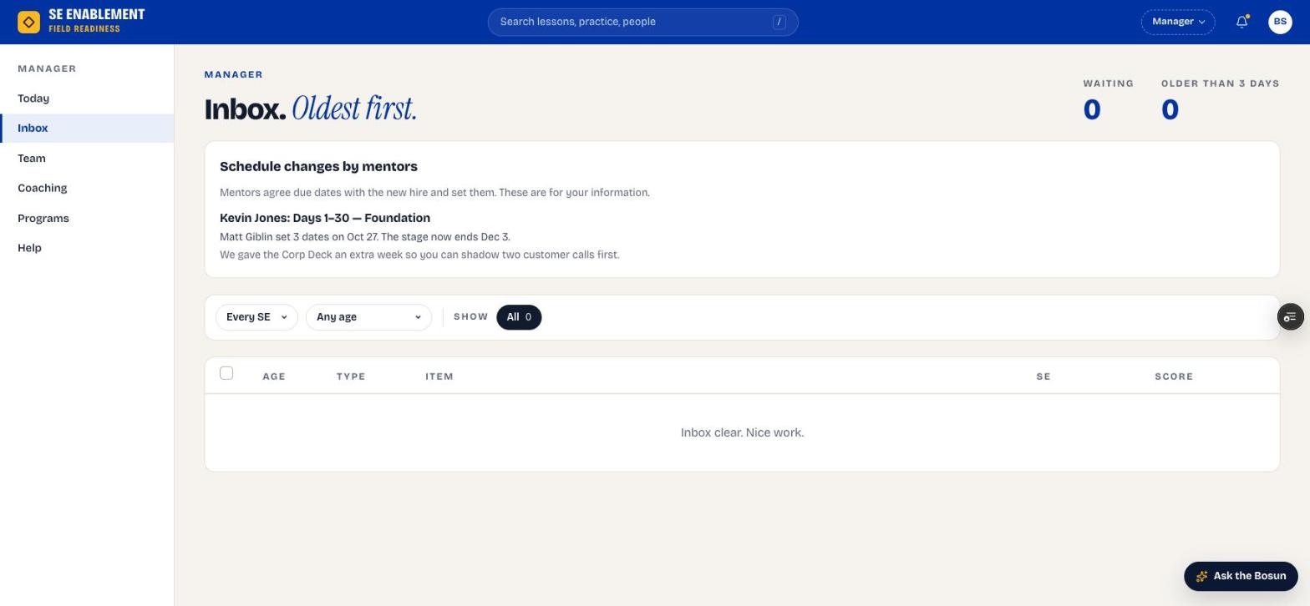
Figure 4.7 — Manager Inbox

4. Read your notifications
- Click the bell. Notifications open in a workbench; click one to go to it, or Mark all read.

Why it matters: Notifications tell you when a mentor sets or changes the schedule, so you're never surprised by a new date.
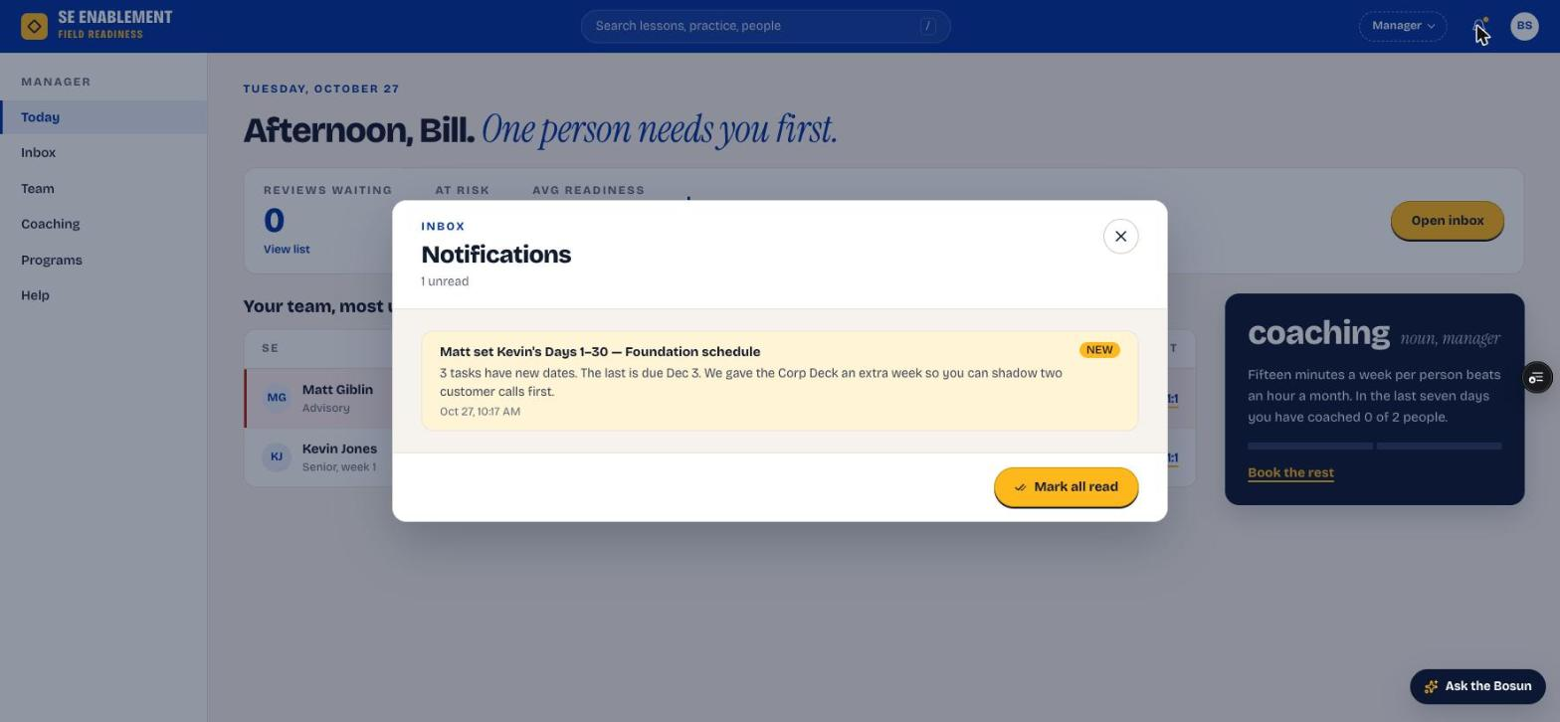
Figure 4.8 — Notifications workbench

5. Sign off stage gates
- When the new hire submits a test-out or the end-of-stage sign-off, it appears in your Inbox and on their profile.
- Open it, review the evidence against the criteria, and approve or send it back.

Why it matters: Signing off the gate unlocks the next 30-day stage. This is the manager's decision because it confirms the new hire is ready to move on.

Appendix A — Notifications
Who is told what, and when.
Event | Who is told | What they see
Plan assigned | New hire | Who assigned which program, who the mentor is, and that dates are agreed at the first 1:1.
Plan assigned | Mentor | That they're mentoring the new hire, with next steps: read the brief, meet, set the schedule.
Mentor sets the schedule | New hire and manager | How many dates changed, the new stage end and the mentor's note.
Mentor logs a 1:1 | New hire | The next actions from the meeting.
Manager schedules a 1:1 | New hire, and mentor if invited | Date, time, length and who's joining. It also appears under Coming up on the new hire's Today page.
New hire submits a step | Reviewer (mentor or manager) | That work is waiting. The mentor's Today and Mentoring pages count it.
Mentor approves or sends back | New hire | The decision, the step and the mentor's note.

Appendix B — Quality notes from the walkthrough
This guide was produced by running the workflow end to end on the live platform. Problems found along the way were logged and fixed before moving on, so the steps above describe the corrected behaviour.
- 65 items logged; almost all fixed and released during the walkthrough.
- Workflow fixes: mentors can approve everyday steps; the new hire's answer is kept when a step is reviewed; the mentor sets dates without approval; the new hire and manager are told about every schedule change; scheduled 1:1s are saved and shown.
- Accuracy fixes: new starters are no longer flagged as at risk; a mentor's work counts as them being active; the next certification gate is the earliest one not yet cleared; reviewer names are correct on both sides.
- Usability fixes: detail views open as workbenches instead of expanding inline; Mentoring shows only for mentors; the new hire sees their mentor on Today and My ramp.
- Speed: sign-in checks run locally, and the app now runs in the same region as its database. Pages load 25–35% faster.
- Still open (minor): Today still offers "Schedule a 1:1" when one is already booked; the coaching card doesn't count scheduled 1:1s; outbound email needs the email service key configured.

